CYCLES IN NATURE

Elements such as carbon, oxygen, hydrogen, nitrogen and sulphur are recycled in nature - this is the role of the decomposers.

Carbon Cycle

The element carbon is one of the main materials in sugars, proteins and fats - these are found in the tissues of all living things. Carbon is also found in vitamins, as well as in waste products such as CO₂ and urea.

In the carbon cycle, plants convert CO₂ to food and O₂ during photosynthesis.

Animals (and plants at night) produce CO₂ during respiration.

On decomposition, all plant and animal material is reduced to CO₂ by the decomposers, and the residual nutrients are returned to the soil.

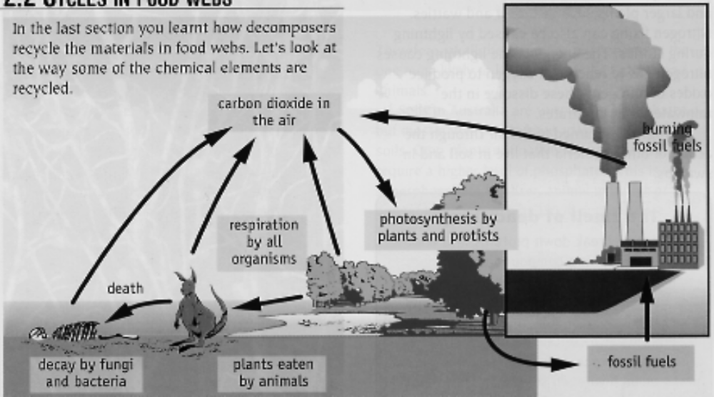

Nitrogen Cycle

Nitrogen makes up 78% of the atmosphere, is found combined with oxygen as nitrates in the soil, and is one of the elements found in proteins (these are the building blocks of cells and tissues).

Animals obtain their nitrogen either from plants or other animals.

Plants get their nitrogen from the nitrates in the soil. They are soluble in water and are easily absorbed by plant roots.

Nitrates can be formed in the following ways.

• The decay of dead organisms by decomposers.

• Atmospheric nitrogen changed by nitrogen-fixing bacteria in the soil and
in nodules on the roots of legumes such as clover, peas and beans.

• Lightning causes atmospheric nitrogen N₂ to react with O₂ to form oxides
of nitrogen. These form nitrates when they dissolve into water.

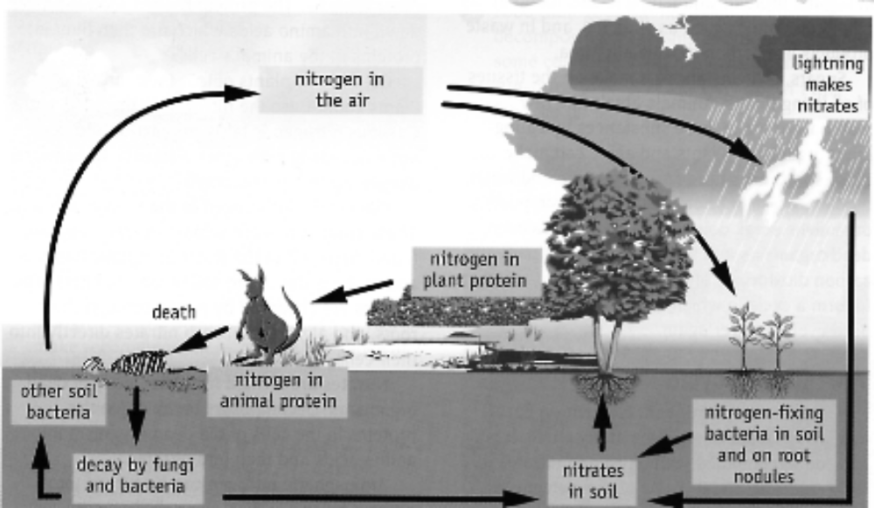

Water Cycle

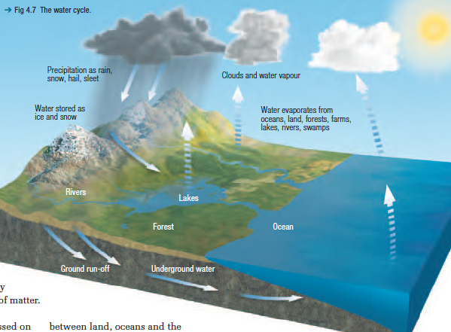

The global water cycle is driven by heat from the Sun. Three major
processes driven by solar heat.

• Precipitation (rain, snow, sleet),
• Evaporation
• Transpiration from plants—continuously move water

Humans can alter the water cycle.

e.g. Cutting down rainforests changes the amount of water vapour in the
air (due to transpiration), which alters precipitation.

Water is not available equally in all ecosystems. Water that is evaporated from a
desert may later fall as rain on a forest thousands of kilometres away.

e.g. Australia is a good example of this situation. Some areas may be in
drought and others may have floods, and organisms in ecosystems in
both areas may be affected.

